Event for Project “Pharmaceuticals in wastewaters – levels, impacts and reduction” (LLI-527)
“MEDWWater” - activities implemented within the project, achieved results and experts’ suggestions
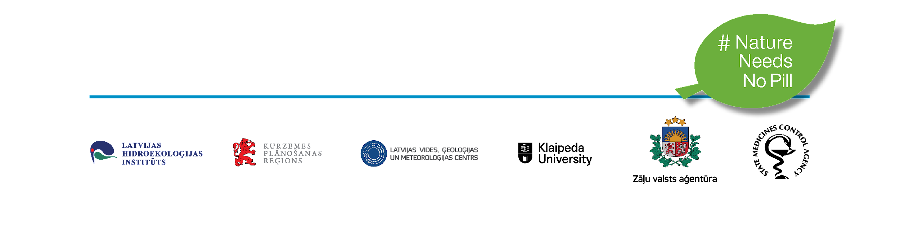
18th of April, 2023 10:00 am - 13:30 pm, on Zoom
AGENDA
9:45 - 10:00 | Registration
10:00 - 10:05 | Moderator introduces with the plan of Event and some technical  details
10:05 - 10:25 | "Project MEDWwater – its origins, aims,  activities, and results achieved" by Ieva Putna-Nīmane, researcher at Latvian Institute of Aquatic Ecology Agency of Daugavpils University (LIAE)
10:25 - 10:40 | Campaign "Nature needs no pill" by Liena Freimane, Kurzeme Planning region
10:40 - 10:50 | “The role of pharmacies in reducing pharmaceutical contamination” by Kristīne Jučkoviča, executive Director of Association of Pharmaceutical care of Latvia
10:50 – 11:05 | "Pharmaceuticals loads in wastewaters from Lithuania and Latvia" by Dr. Sergej Suzdalev, researcher at University of Klaipeda (KU)
11:05 - 11:20 | "Suggested active pharmaceutical ingredients for future monitoring" by Anete Kubliņa, senior specialist at Latvian Environment, Geology and Meteorology Centre (LEGMC)
11:20 – 11:35 | Project MEDWwater – ecotoxicity results of treated and untreated wastewaters and reduction of negative effects” by Ieva Putna-Nīmane, researcher at Latvian Institute of Aquatic Ecology Agency of Daugavpils University (LIAE)
11:35 - 11:50 break/ presentation of educational videos
11:50 - 12:15 | “Recommendations for wastewater treatment plants for safe removal of pharmaceuticals” by Erki Lember (ME Water Consult OÜ)
12:15 – 12:35 | “Brief insights of the technical consultation for Lithuanian and Latvian wastewater treatment plants” by Michael Stapf
12:35 – 13:05 | “Changes in wastewater management included in the proposal for a Directive concerning urban wastewater treatment (recast)” by Iveta Teibe, Head of Water Resource Division, Ministry of Environmental Protection and Regional Development of the Republic of Latvia
13:05 - 13:30 | Panel discussion  Participants:  Iveta Teibe, Head of Water Resource Division, Ministry of Environmental Protection and Regional Development of the Republic of Latvia  Erki Lember, ME Water Consult OÜ  Michael Stapf, environmental engineer  Ieva Putna-Nīmane, researcher at LIAE  Dr. Sergej Suzdalev, researcher at KU  Anete Kubliņa, senior specialist at LEGMC  Liena Freimane, Kurzeme Planning region
Moderator - Sandra Kropa-Kaļužnaja

Erki Lember has worked in the water and wastewater treatment sector since 2012. He has been the Tallinn wastewater treatment plant's chief technologist and later worked on different research projects. Erki holds a PhD from Tallinn University of Technology in the field of environmental engineering. In the last 8 years, he has been involved in many research projects connected with harmful substances in wastewater and their removal, which included pharmaceutical residues. Besides his university career, Erki works as a freelance consultant and helps water utilities in wastewater treatment process management and optimization, process modelling, energy reduction, investment decisions etc.

Michael Stapf is an environmental engineer, for more than 10 years working as a researcher in the field of advanced wastewater treatment. Main focus of Michael’s activities related to the removal of micropollutants / APIs from the wastewater flows, ozonation of wastewater, analysis of water reuse possibilities. He has been involved in many national (German) and international initiatives related to the anthropogenic trace organic compounds and pathogens, including pharmaceuticals pollution (e.g., CWPharma 1/2).

Kristine Juckovica is the Executive Director of Association of Pharmaceutical care of Latvia, which unites four biggest pharmacy enterprises of Latvia; member of the executive committee of PGEU for community pharmacists in Europe; member of the Council of Pharmaceuticals at Ministry of Health of Latvia.

Public event is organised in the frame of the EU funded (Interreg Latvia-Lithuania Program) project “Pharmaceuticals in wastewaters – levels, impacts and reduction”, (MEDWwater, LLI-527).
Please note that photographs and footage will be taken throughout Event. These will be used by the Project`s reports.

