24 September 2025

SPOR Portal – Alternative access solution
Guidance to SPOR users

Table of Contents
1. Background 3
2. SPOR portal 3
2.1. OMS portal 3
2.2. RMS portal 4
3. EMA Service Desk portal 4
3.1. OMS Change requests 4
3.1.1. Add Organisation 5
3.1.2. Add Location 8
3.1.3. Update Organisation 11
3.1.4. Update location 12
3.2. OMS exports 14
3.3. RMS Change requests 16
3.3.1. Add list 16
3.3.2. Update list 17
3.3.3. Add term 18
3.3.4. Update term 21
3.3.5. Delete term 24
3.4. RMS exports and translations 26
4. Document History 27

- Background
To further consolidate its request management, the European Medicines Agency is further integrating the EMA Service Desk as the central point of contact for all change requests to further optimize customer service and explore operational efficiencies. We appreciate your collaboration and understanding for any inconvenience this might cause short-term.
We recognise that many of you are already well-acquainted with the EMA Service Desk’s advanced ticketing system and interactive chat functionalities. Accordingly, we anticipate a seamless transition for the majority of users. Please be assured that we remain committed to the ongoing enhancement of the request management process for SPOR-related services, ensuring the highest standard of support and efficiency.

- SPOR portal
The SPOR portal currently offers only guest access (no login) to query and browse OMS, RMS and SMS data.
  - OMS portal
As of 1 October 2025, OMS change requests, request an export containing all organisation with history and result specific exports should be submitted through the EMA Service Desk.
An export with all ACTIVE OMS record is published daily under OMS document section as A7 - Export All Organisations.
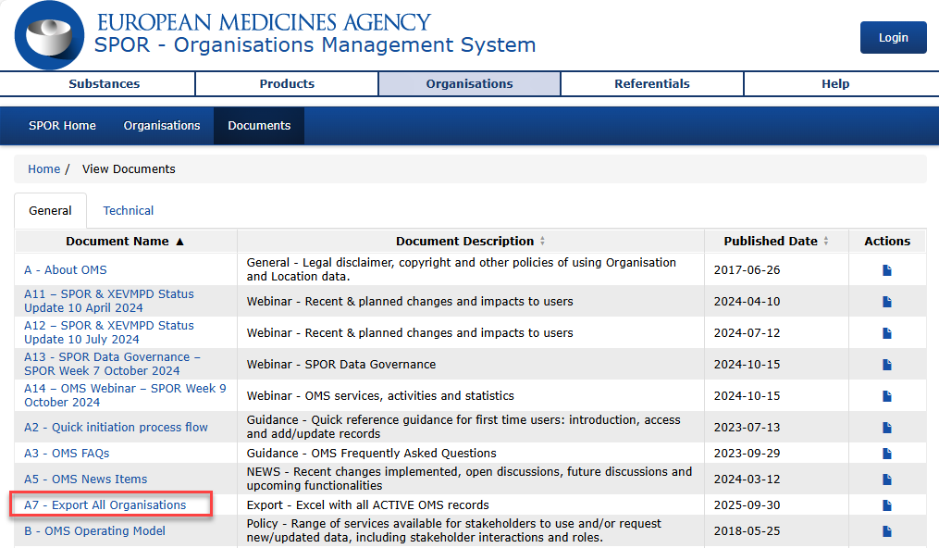
  - RMS portal
As of 1 October 2025, RMS change requests and requests for list exports and translations should be submitted through the EMA Service Desk.

- EMA Service Desk portal
The EMA Service Desk portal is now the interface used to submit OMS, RMS and SMS change requests and to request other information such as exports, RMS translations, etc.
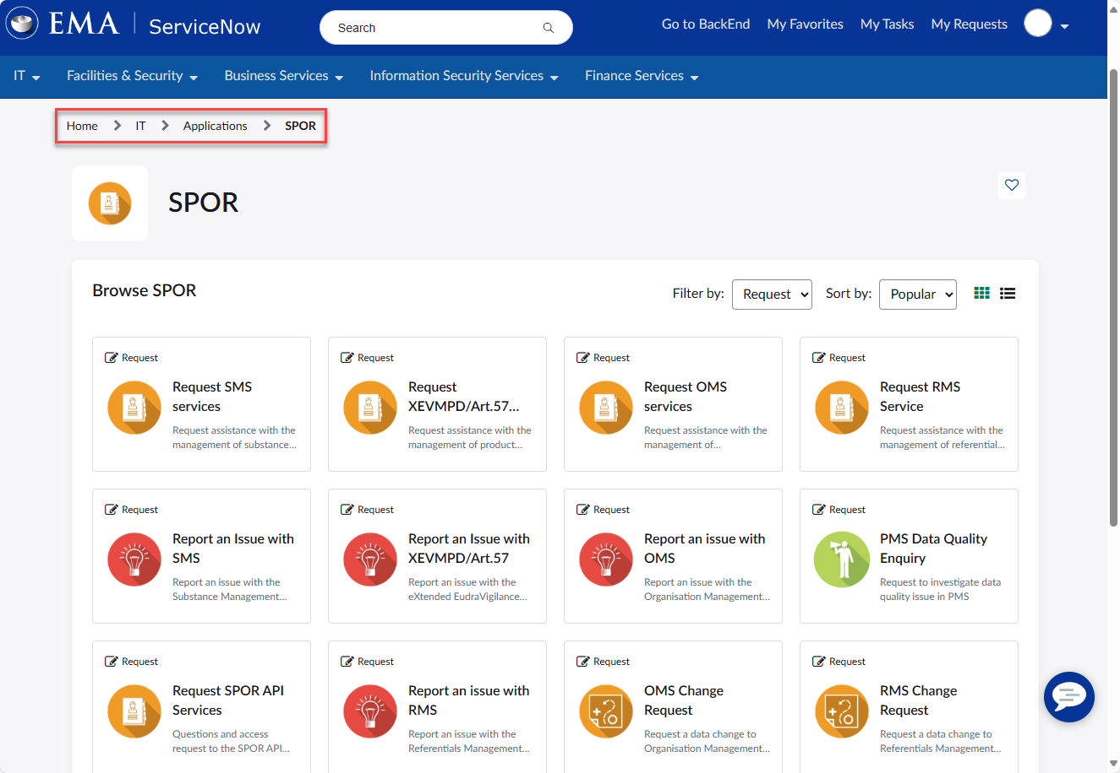
  - OMS Change requests
Before submitting any request to the OMS, the user must search the available records in the OMS portal. Based on the search results a change request may be required to:
- Add Organisation – if the user can to find the requested organisation – defined by name and country;
- Add Location - if the organisation is found, but the required location is not;
- Update Organisation – user can locate an organisation but determines that the organisation need to be changed;
- Update location - user can locate a location but determines that the location need to be changed.
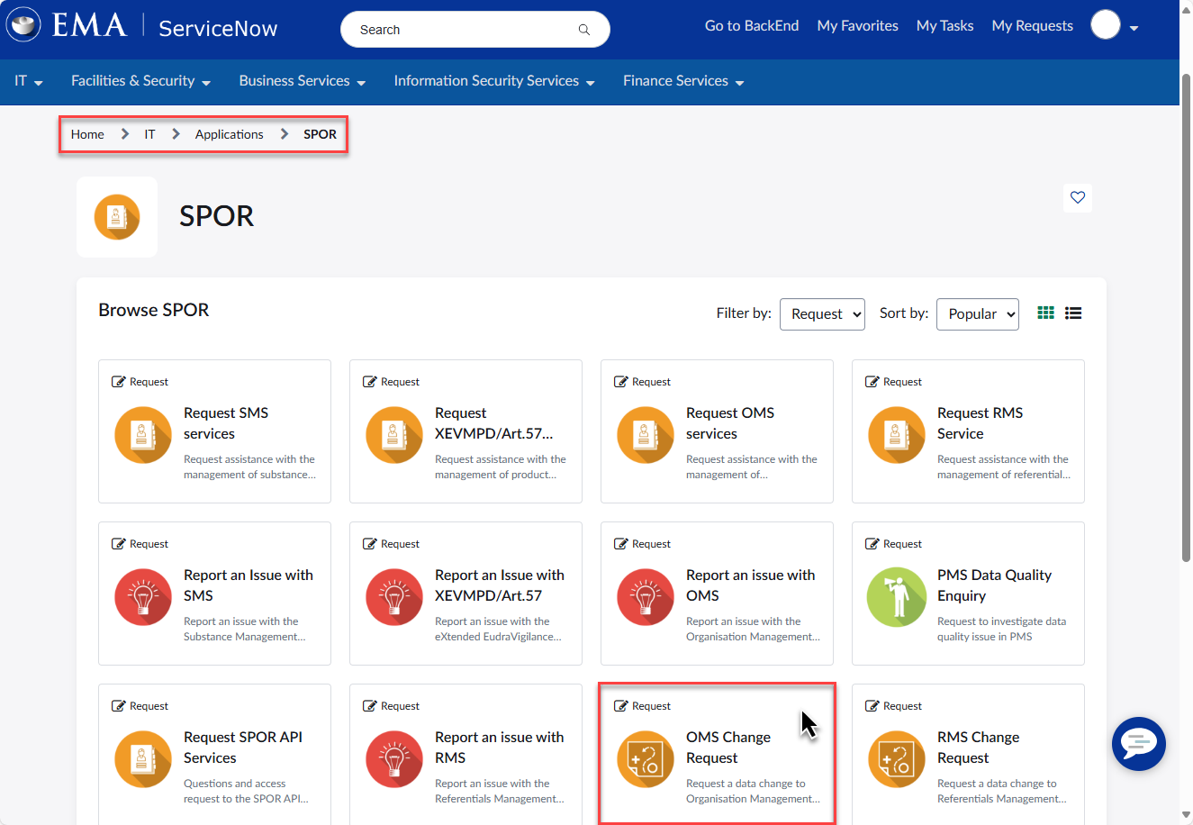
    - Add Organisation
After query the OMS portal the user can find the requested organisation – defined by name and country, submit an OMS Change request though EMA Service Desk.
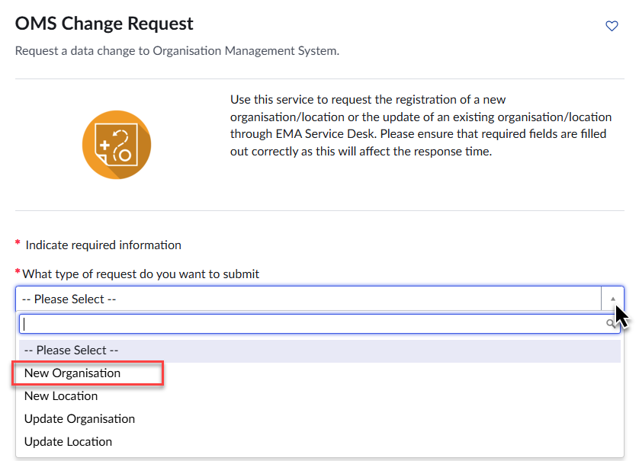
When raising a request to create a new organisation the requestor is required to provide data for the organisation (e.g. organisation name and organisation type), and the physical location (e.g. address). In addition, other Location related information can be provided such as telephone number, email address, DUNS and/or GS1 numbers.
Only data for a single location can be provided with each request; therefore, if a new organisation requires multiple locations a request must initially be raised to create the organisation and its initial location. Once the new organisation has been approved, additional requests need to be raised to add the additional locations (one request per location).
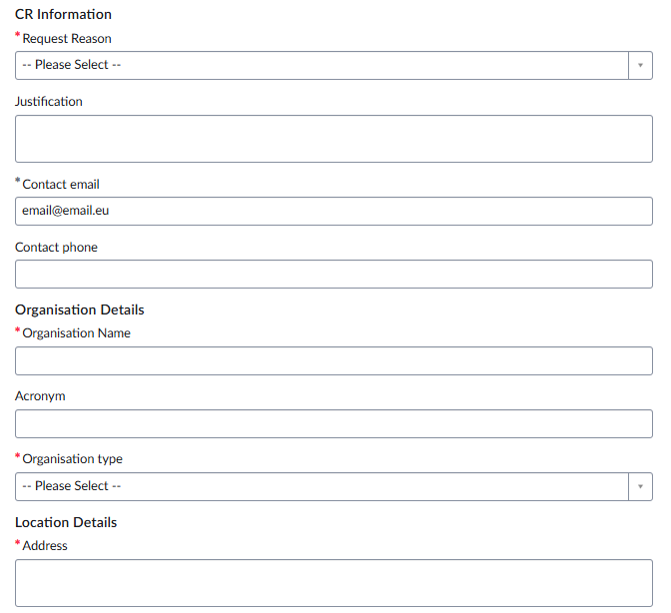
Business rules:
- Mandatory fields are marked by red asterisk - *.
- Request reason needs to be chosen from the drop-down list as appropriate. Please note that it covers the comments and requestor details when expanded; it collapses after a choice is made.
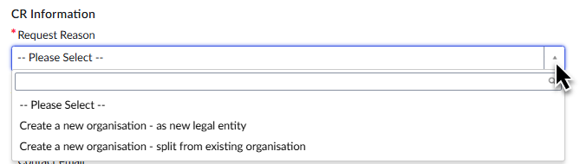
- Organisation is country specific – i.e. the country of the first location determines the country for all associated locations;
- Preferred language is English. Organisation and location details can also be entered in other EEA official languages, but the system will supplement the record with English transcription where possible.
- E-mail addresses must contain “@” and “.”.
- Organisation type is a drop-down list – the requestor needs to choose what is most appropriate from the options available. Please note that it covers the address when expanded; it collapses after a choice is made;
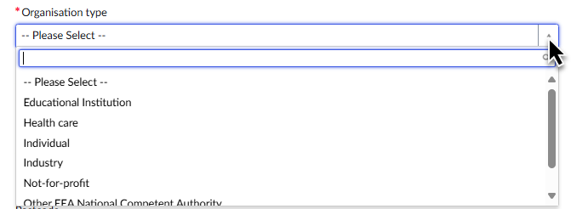
- Contact phone numbers needs to contain the country code;
- • DUNS number and GS1 number are not mandatory but should be provided if available as they provide data quality reassurance;
- Once submitted, the request cannot be edited or resubmitted
Attachments:
- To support a change request, documents must be submitted to allow the EMA data stewards to validate the request. For further information on the type of document to be submitted please review the document E - OMS Change requests available under OMS portal document section;
- The documents are added in the Add attachments section at the end of the request form.
    - Add Location
After query the OMS portal the user can find the organisation, but not the required location, submit an OMS Change request though EMA Service Desk.
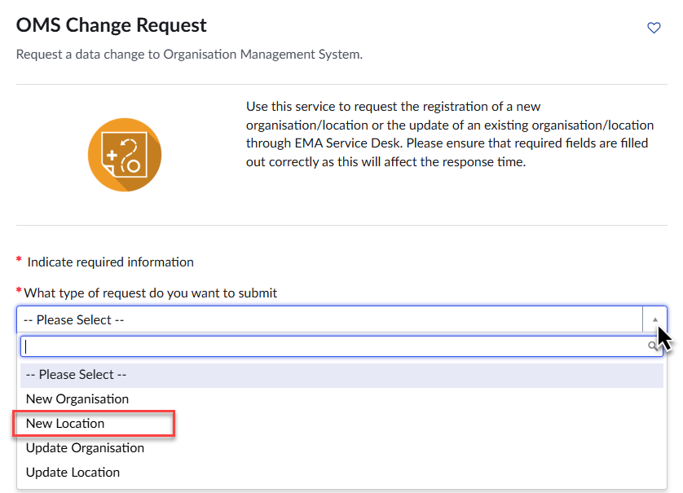
A new location can be added to an existing organisation by this process. The requestor is required to provide data for the new physical location (i.e. address, phone/e-mail, DUNS/GS1 numbers).
Only data for a single location can be provided with each request; therefore, if a new organisation requires multiple locations a request must initially be raised to create the organisation and its initial location. Once the new organisation has been approved additional requests need to be raised to add the additional locations (one request per location).
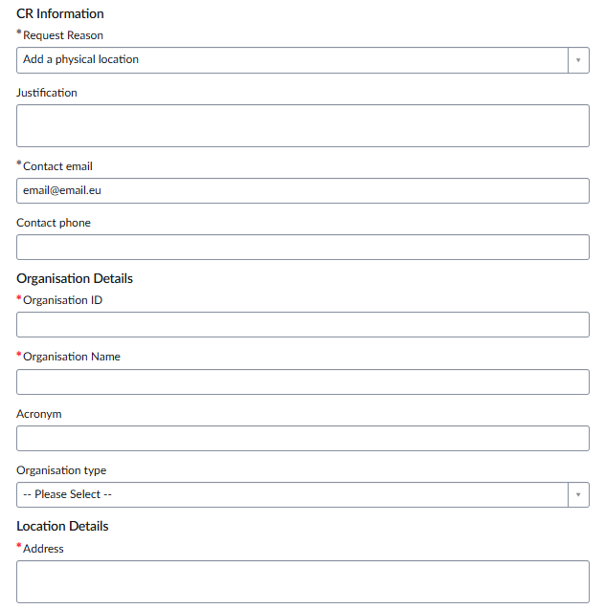
Business rules:
- Mandatory fields are marked by red asterisk - *;
- Organisation ID and organisation name need to be manually populated. Ensure the details are accurate accounting to the existing data in OMS e.g. organisation ID belongs to the organisation name added to the form;
- Organisation is country specific – i.e. the country of the organisation determines the country for all associated locations. Therefore, ensure you select the correct country from the dropdown list;
- If the requested location is not in the same country as the first location, please request creation of a new organisation;
- Preferred language is English. Organisation and location details can also be submitted in other EEA official languages but the system will supplement the record with English translation/transcription where possible;
- E-mail addresses must contain “@” and “.”;
- Contact phone numbers need to contain the country code;
- DUNS number and GS1 number are not mandatory but should be provided if available as they provide data quality reassurance;
- Once submitted, the request cannot be edited.
Attachments:
- To support a change request, documents must be submitted to allow the EMA data stewards to validate the request. For further information on the type of document to be submitted please review the document E - OMS Change requests available under OMS portal document section;
- The documents are added in the Add attachments section at the end of the request form.
    - Update Organisation
After query the OMS portal the user can locate an organisation but determines that the organisation need to be changed, submit an OMS Change request though EMA Service Desk.
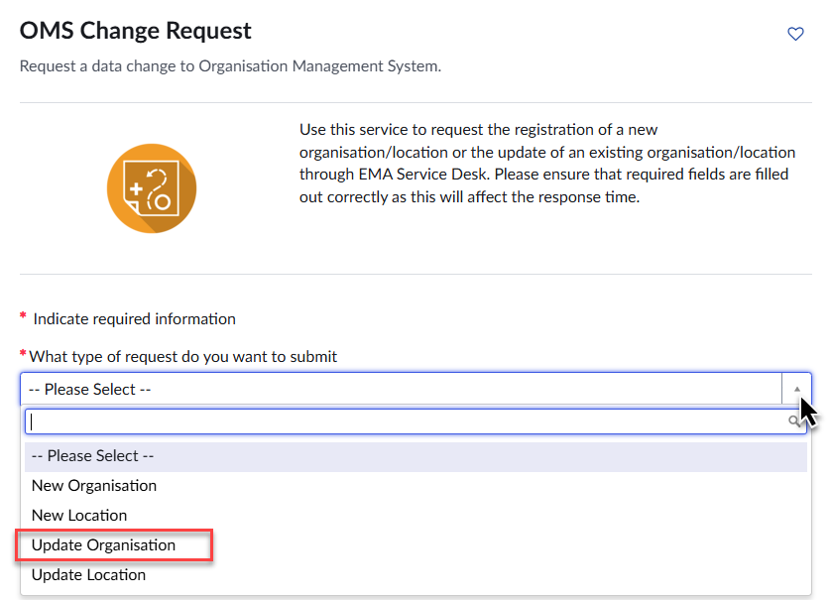
Business rules:
- Mandatory fields are marked by red asterisk - *;
- Request reason needs to be chosen from the drop-down list as appropriate. Please note that it covers the comments and requestor details when expanded; it collapses after a choice is made;
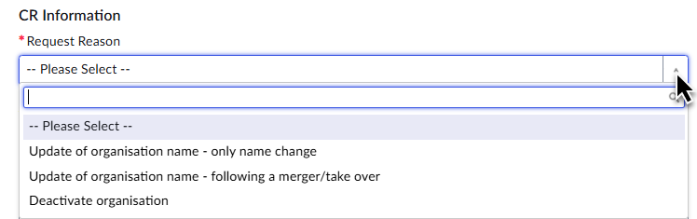
- Organisation ID and organisation name need to be manually populated. Ensure the details are accurate accounting to the existing data in OMS e.g. organisation ID belongs to the organisation name added to the form;
- Preferred language is English. Organisation and location details can also be entered in other EEA official languages but the system will supplement the record with English transcription where possible;
- When populate the Organisation type ensure the information reflect the OMS data. If the Organsation type needs change please use the dedicated form;
- Once submitted, the request cannot be edited.
Attachments:
- To support a change request, documents must be submitted to allow the EMA data stewards to validate the request. For further information on the type of document to be submitted please review the document E - OMS Change requests available under OMS portal document section;
- The documents are added in the Add attachments section at the end of the request form.
    - Update location
After query the OMS portal the user can locate a location but determines that the location need to be changed, submit an OMS Change request though EMA Service Desk.
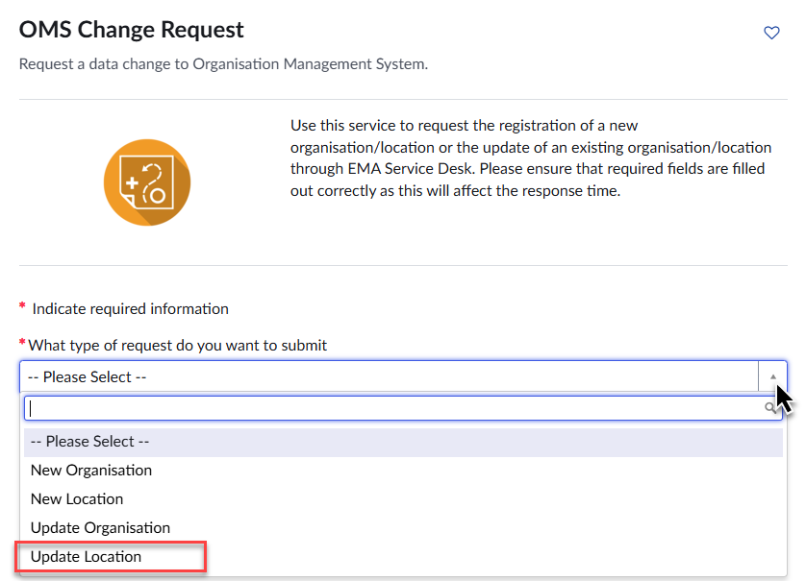
Business rules:
- Mandatory fields are marked by red asterisk - *;
- Request reason needs to be chosen from the drop-down list as appropriate. Please note that it covers the comments and requestor details when expanded; it collapses after a choice is made;
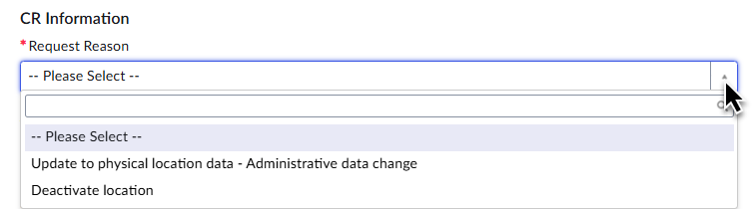
- Organisation ID and organisation name need to be manually populated. Ensure the details are accurate accounting to the existing data in OMS e.g. organisation ID belongs to the organisation name added to the form;
- Organisation is country specific – i.e. the country of the organisation determines the country for all associated locations. Therefore, ensure you select the correct country from the dropdown list;
- If the requested location is not in the same country as the first location, please request creation of a new organisation;
- Preferred language is English. Organisation and location details can also be submitted in other EEA official languages but the system will supplement the record with English translation/transcription where possible;
- E-mail addresses must contain “@” and “.”;
- Contact phone numbers need to contain the country code;
- DUNS number and GS1 number are not mandatory but should be provided if available as they provide data quality reassurance;
- Once submitted, the request cannot be edited.
Attachments:
- To support a change request, documents must be submitted to allow the EMA data stewards to validate the request. For further information on the type of document to be submitted please review the document E - OMS Change requests available under OMS portal document section;
- The documents are added in the Add attachments section at the end of the request form.
  - OMS exports
An export with all ACTIVE OMS record is published daily under OMS document section as A7 - Export All Organisations.
To request any other export, use the respective form and select Export all results of an organisation under OMS Request type.
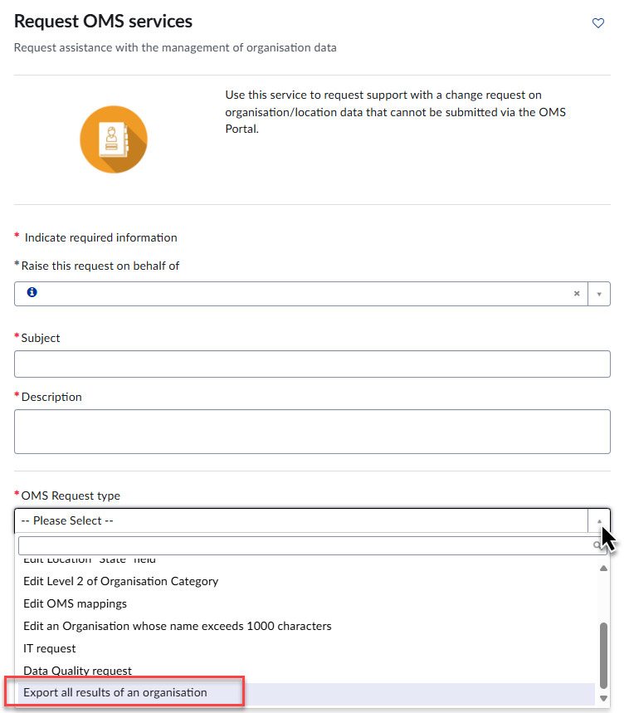
Use the Description to specify if you would like to receive:
- Export All Organisation with History excel;
- Export outcome of a specific search – please provide partial part of the organisation name and country;
- Export with history of a specific search - please provide partial part of the organisation name and country.
  - RMS Change requests
Before submitting any request to the RMS, the user must search the available records in the RMS portal. Based on the search results a change request may be required to:
- Add/update list;
- Add/update/delete term
To submit a request for any of the above-mentioned changes, navigate to the SPOR area in Service Now and click on “RMS Change Request” (see screenshot below).
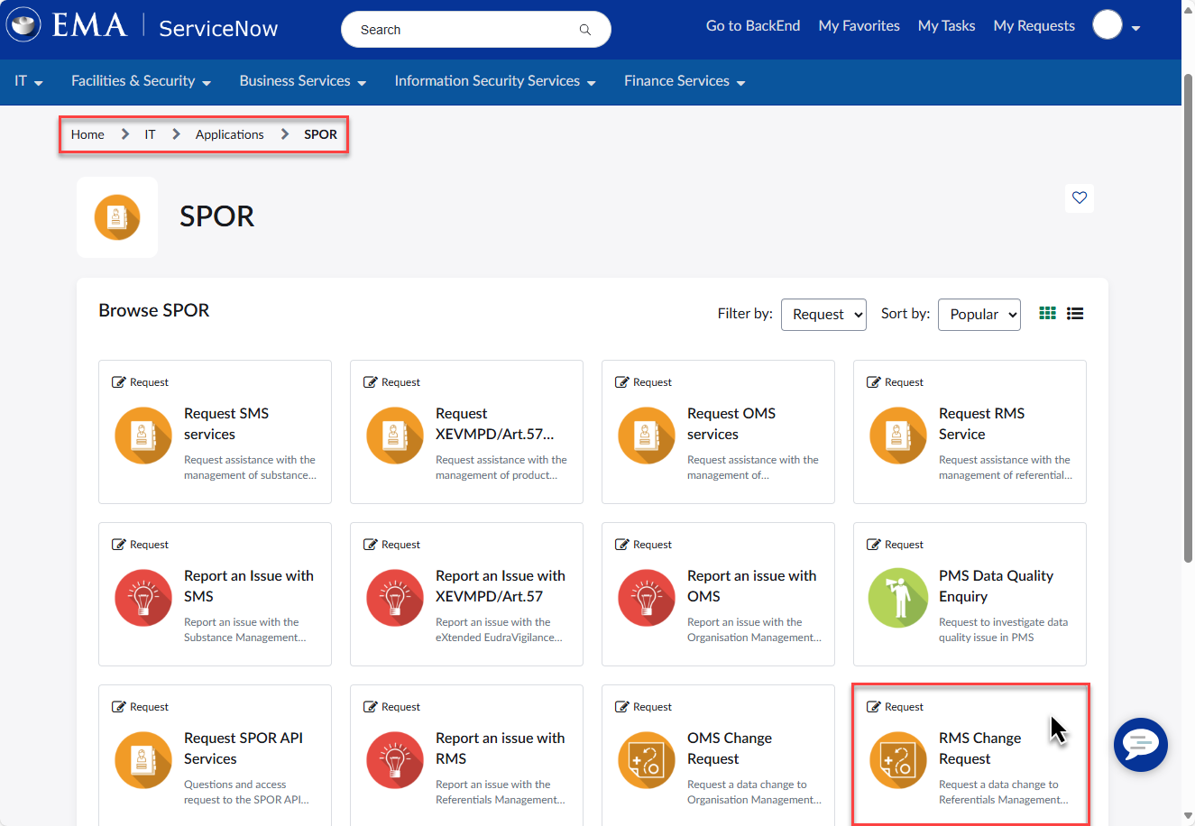

    - Add list
This option should be selected if a new list is required to be implemented in RMS portal.
After clicking on “RMS Change Request”, select the “List Change Request” type and populate the necessary information.
Fields marked with * are mandatory fields and need to be filled in to proceed with the CR.
The CR Name should include the name of the list you wish to add.
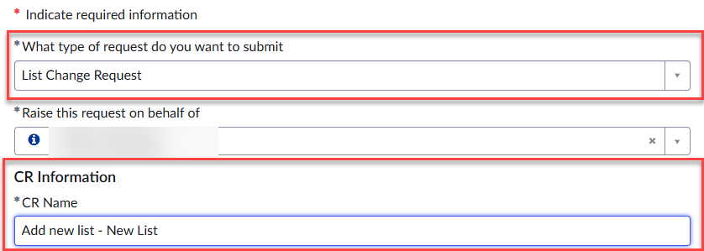
Select CR Type – Add List
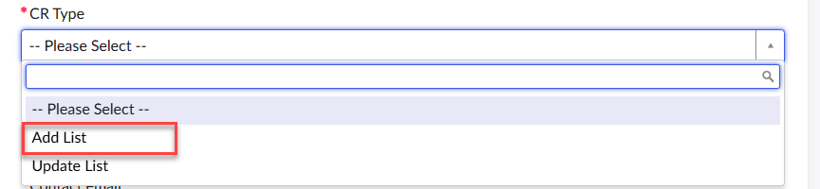
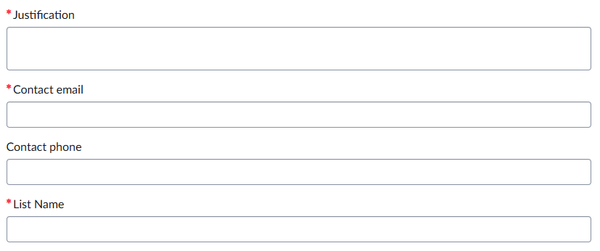
Provide a justification for the creation of the list, a contact e-mail address in case further clarifications are required and the list name as it should appear in the RMS portal.
Last but not list, the draft list should be provided as an attachment using the template for new lists available in the RMS portal (C – RMS New List Template).
    - Update list
This option should be used if any changes to the contents of an already existing list are required.
Fields marked with * are mandatory fields and need to be filled in to proceed with the CR.
Select the “List Change Request” and add the CR name, which should include the name of the list you wish to update.
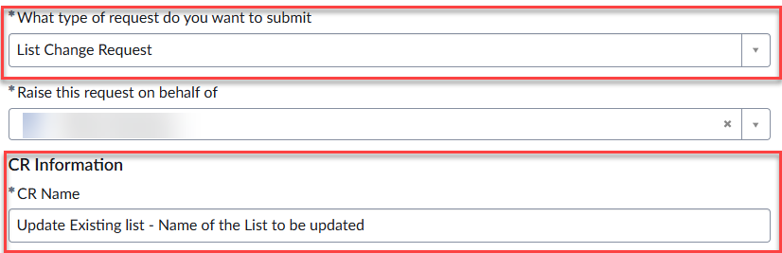
Select CR Type – Update list
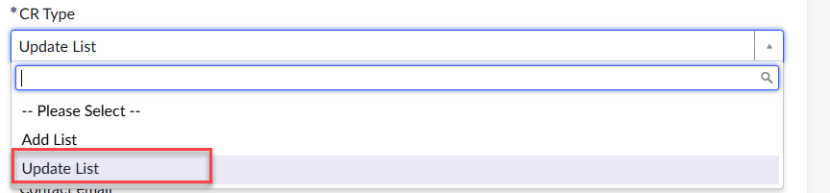
Please provide a justification for the creation of the list, a contact e-mail address in case further clarifications are needed and select the list to be updated from the drop-down menu.
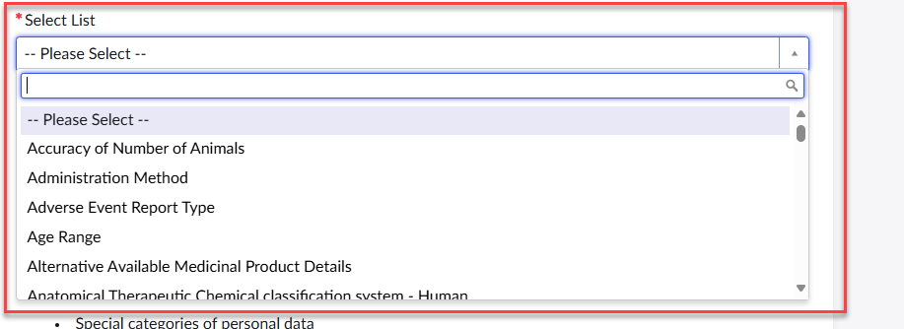
Please provide attachments if applicable with the changes required.
    - Add term
This option should be selected if a new term is required for an already existing list.
Fields marked with * are mandatory fields and need to be filled in to proceed with the CR.
Select the “Term Change Request” option and add the CR name, which should include the name of the term you wish to add. Next, select “Add Term”.
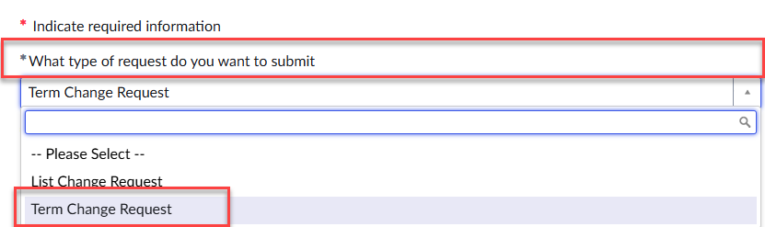
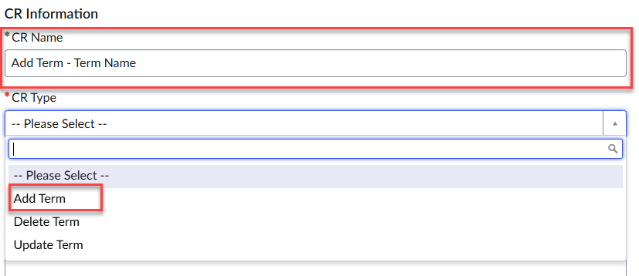
Provide Justification for the creation of the list and a contact e-mail address in case further clarifications are needed.
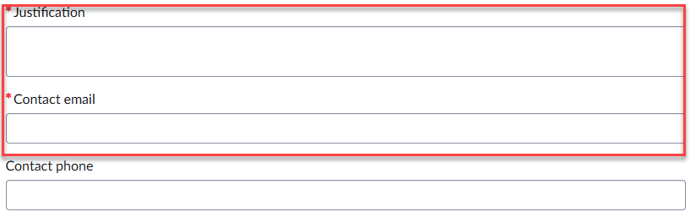
Select list where the term needs to be added from the drop-down menu.
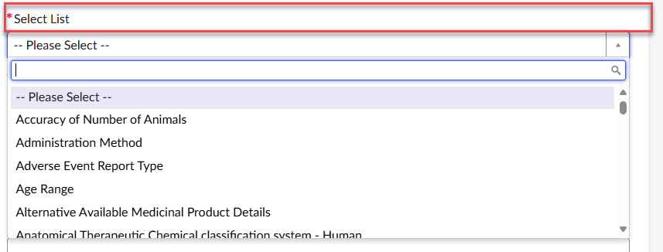
Under the section Term Name, please specify the term name exactly as it should appear on the list.
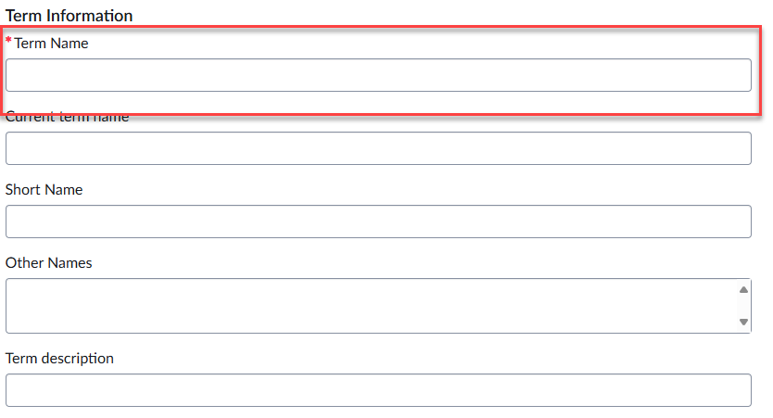
The following fields are optional:
Current Term name – not applicable to add term option
Short name – if needed provide this information
Other names – if needed provide this information
Term description – if needed provide this information
Please note that non-mandatory fields should be filled in if the already existing terms on the list contain this information. The same format should be followed.
Next, select the Domain.
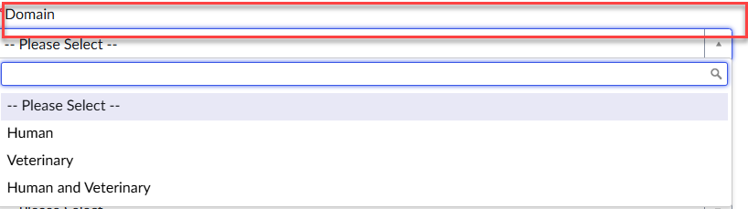
Please fill in the remaining optional fields if relevant.
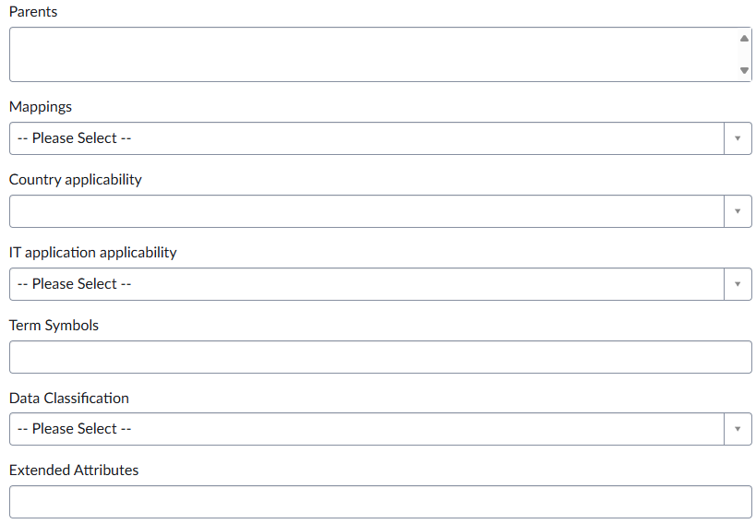
    - Update term
This option should be selected if an existing term needs to be updated.
Fields marked with * are mandatory fields and need to be filled in to proceed with the CR.
Select the “Term Change Request” option and add the CR name, which should include the name of the term you wish to update.
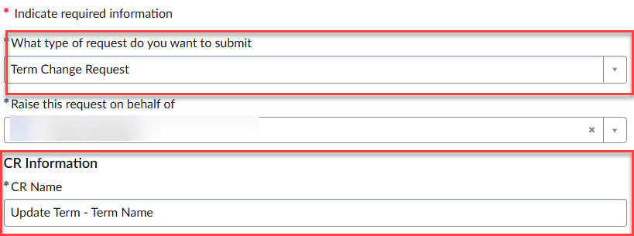
Select CR Type – Update Term
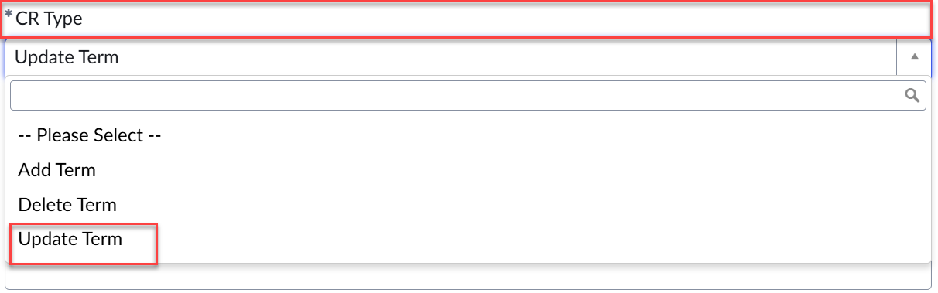
Provide a justification for the term update and a contact e-mail address in case further clarifications are needed.
Select the list that contains the term to be updated from the drop-down menu.
Under the section Term Information, please add the “Term Name” exactly as it should appear on the list as well as the RMS term ID of the term to be updated.
The following fields are optional:
Current Term name – not applicable to add term option
Short name – if needed provide this information
Other names – if needed provide this information
Term description – if needed provide this information
Please note that non-mandatory fields should be filled in if the already existing terms on the list contain this information. The same format should be followed.
Next, select “Domain”.
Please fill in the remaining optional fields as relevant.
    - Delete term
This option should be selected if the existing term is obsolete and should be made non-current. Please note that the term will not be physically deleted but the status will be set to non-current.
Fields marked with * are mandatory fields and need to be filled in to proceed with the CR.
Select the “Term Change Request” option and add the CR name, which should include the name of the term you wish to delete.
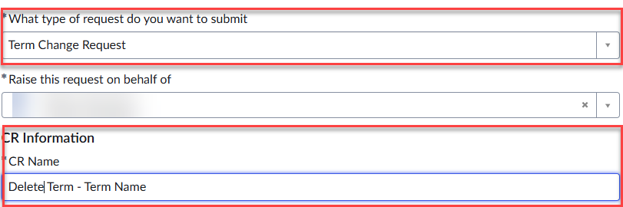
Select CR Type -Delete Term
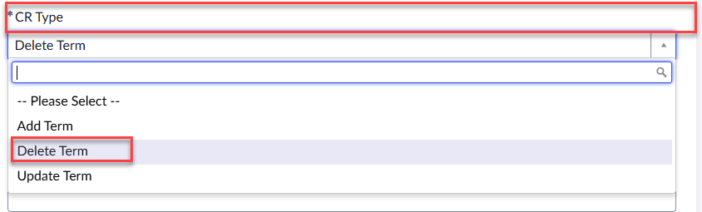
Please provide a justification for the term update and a contact e-mail address in case further clarifications are needed.
Select the list that contains the term to be deleted from the drop-down menu.
Under the section Term Information, please specify the exact term name that needs to be deleted, and include the RMS term ID.
  - RMS exports and translations
RMS exports and translations are no longer available to SPOR users via the RMS portal, although translations can still be browsed in the portal. To obtain an export of a list, or to provide translations of RMS requests, a request via EMA Service desk should be raised by selecting the “Request RMS Service” button in Service Now.
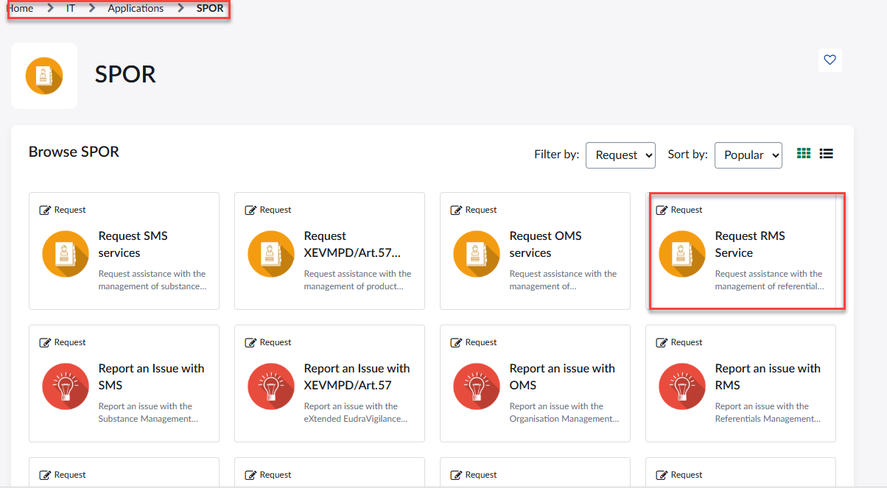

For RMS exports, the user should indicate the list(s) required and whether the export should be in csv or xml format.
NCAs requiring new or updated translations of RMS terms should specify the list(s) as well as the term name(s) and term ID(s) for which they would like to provide translations. If all terms are needed, please specify it in the ticket. The language in which translations will be provided should also be specified in the ticket.
EMA will then provide a file where NCA users should add the translation(s) offline and once completed the user should resubmit it through the same ticket for EMA to upload.

- Document History
Date Version | Reason
01/10/2025  14/10/2025 | First publication.  Modification of section 3.4. RMS exports and translations

